Edge Case and Bug documentation

Sign in
Email without '@'
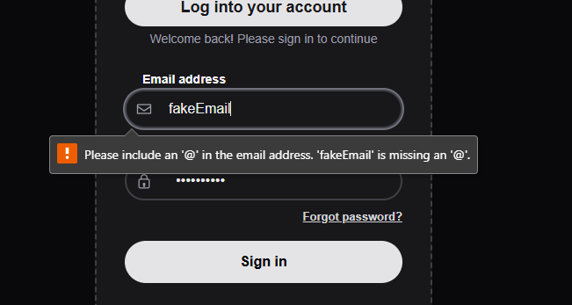
Incorrect email and password
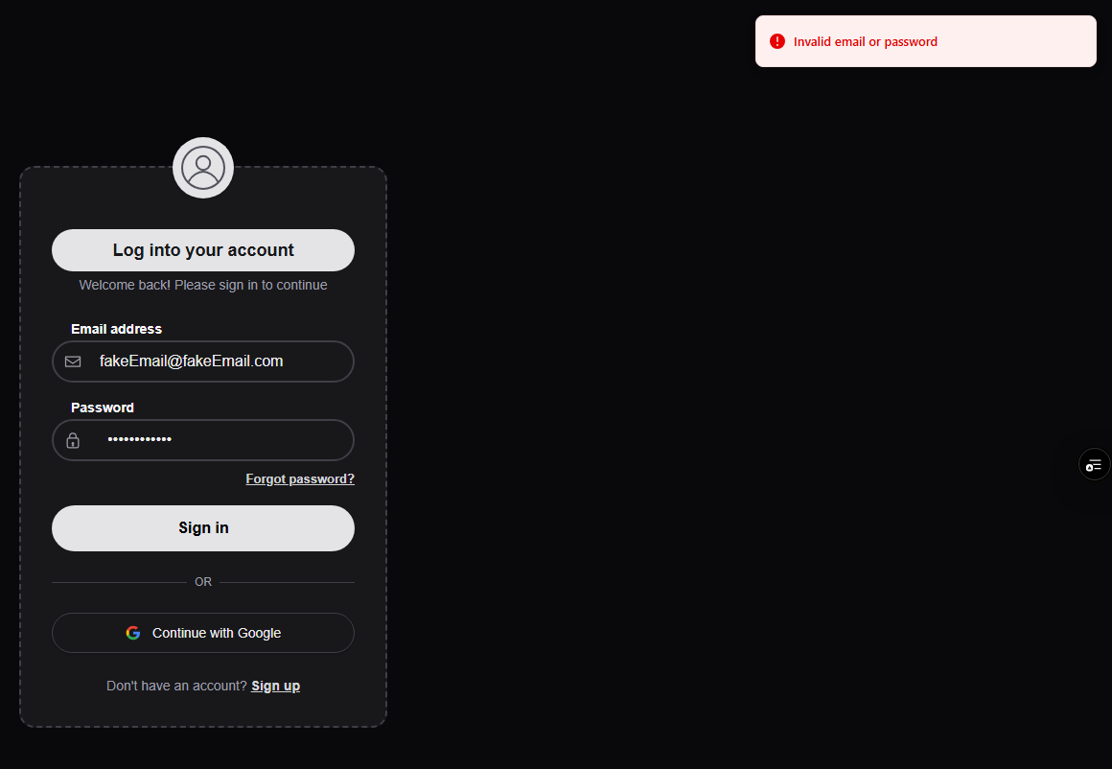
Incorrect email
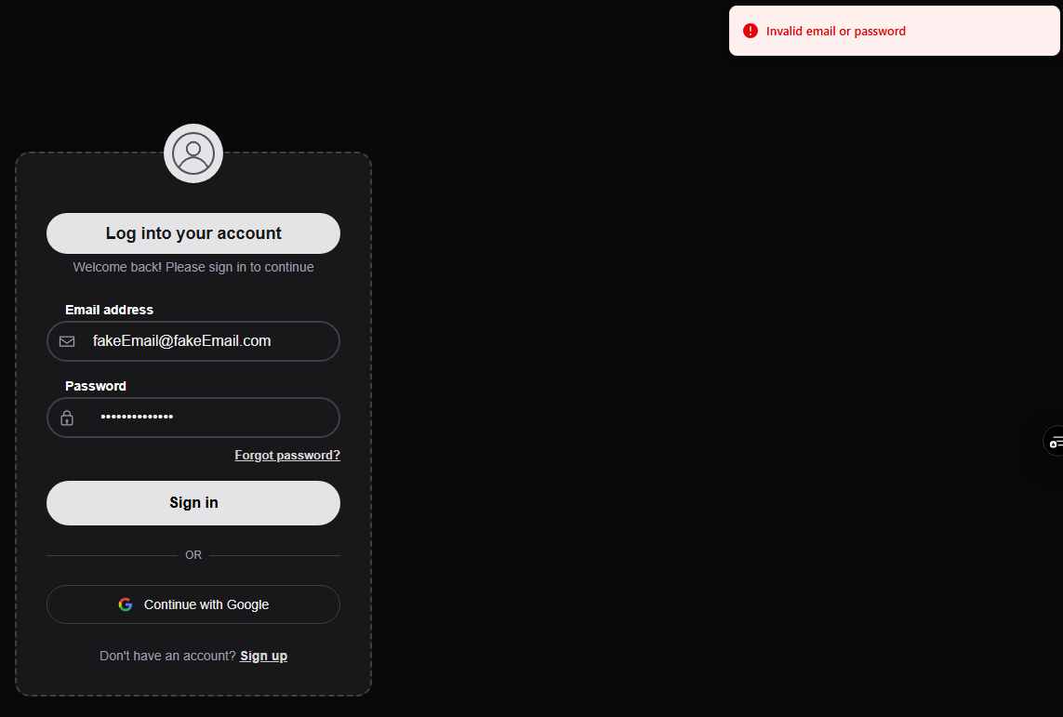
Incorrect password
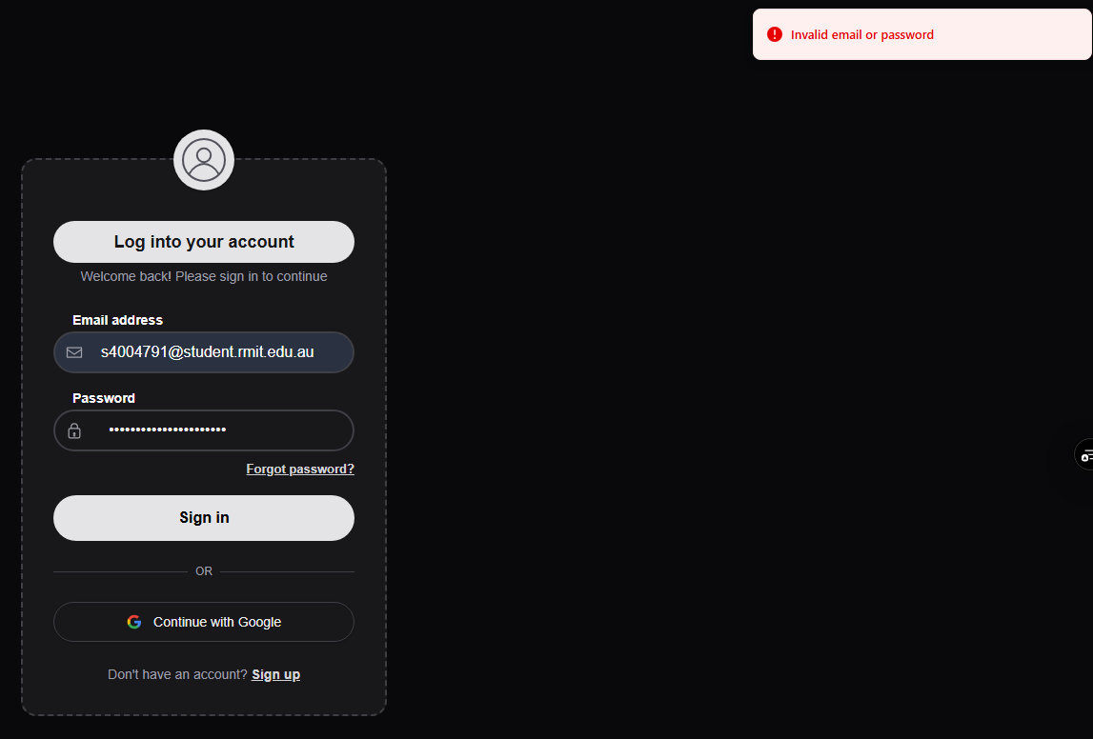
Correct email and password
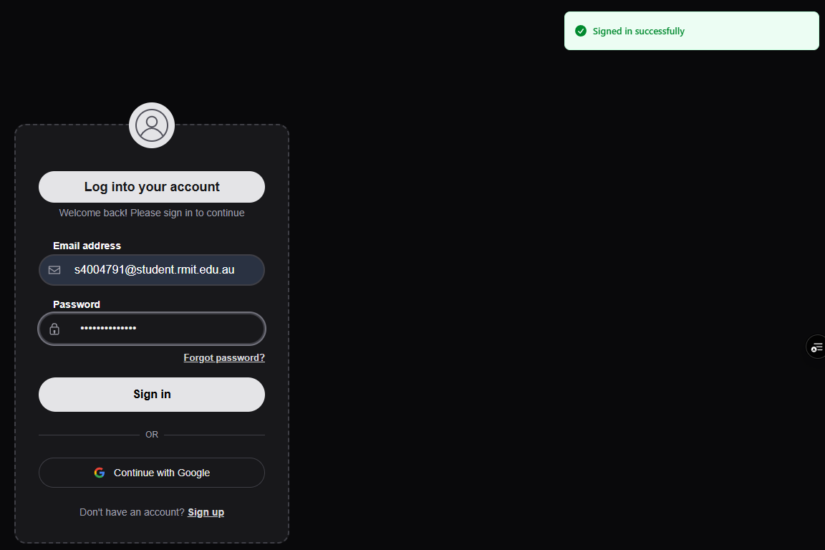
Sign up
Email of already made account
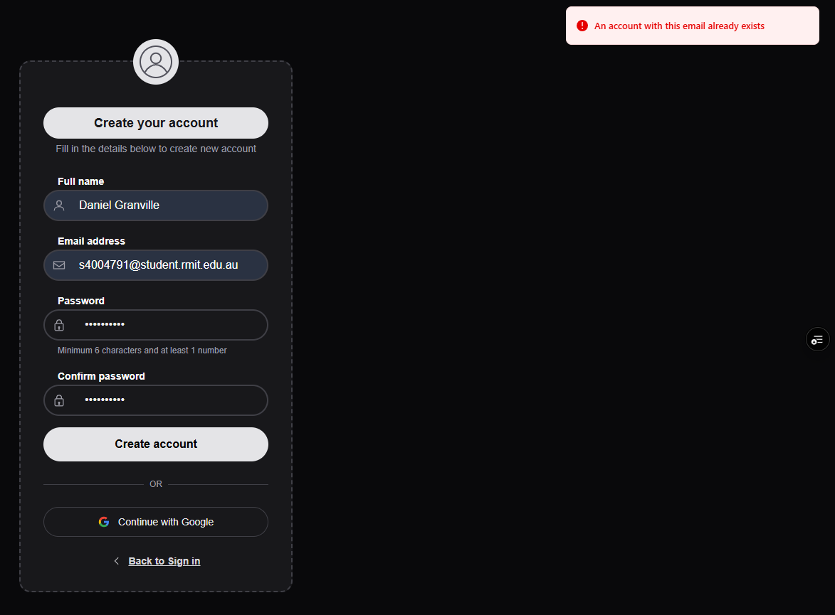
Making notes
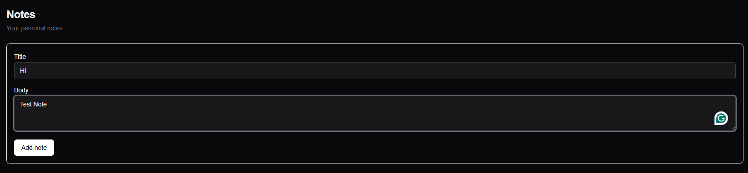
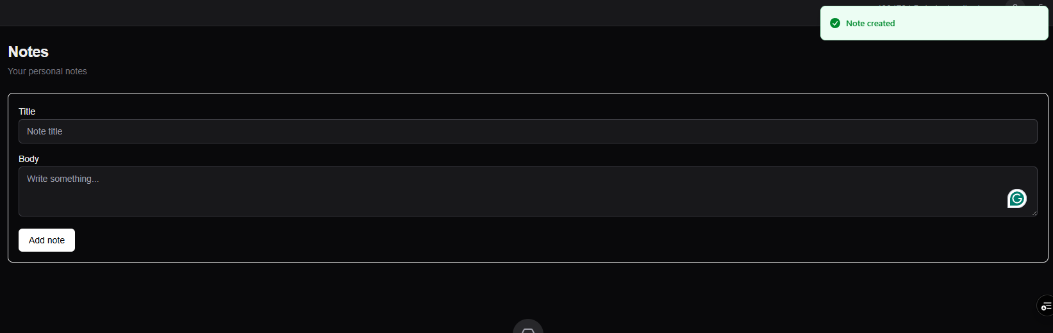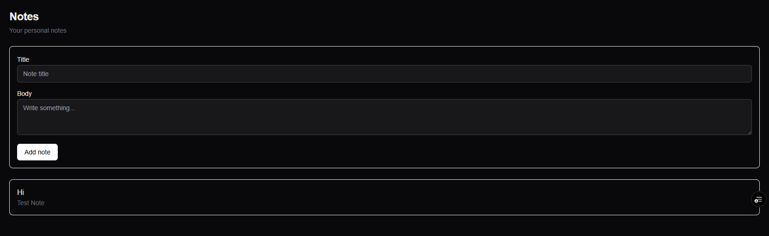

Transitioning using sidebar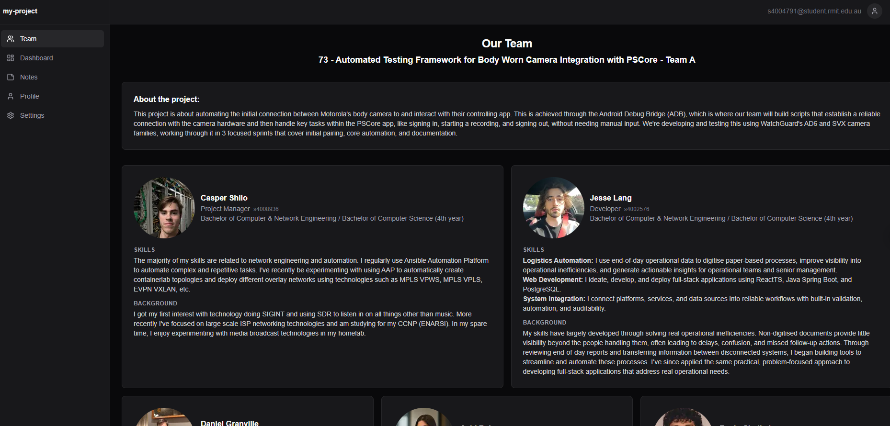
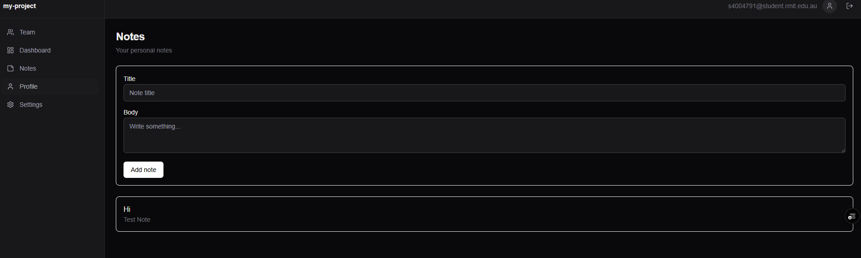
trying to load team-page without signing in: redirects to login screen

Bugs found:
While testing, no bugs were found, every interaction with the webpages left and appropriate response and functioned correctly.

